APP AND WEB SERVERS
TASK 1 : Install nginx and run nginx on port number 81.
I have created ec2 instance and connected
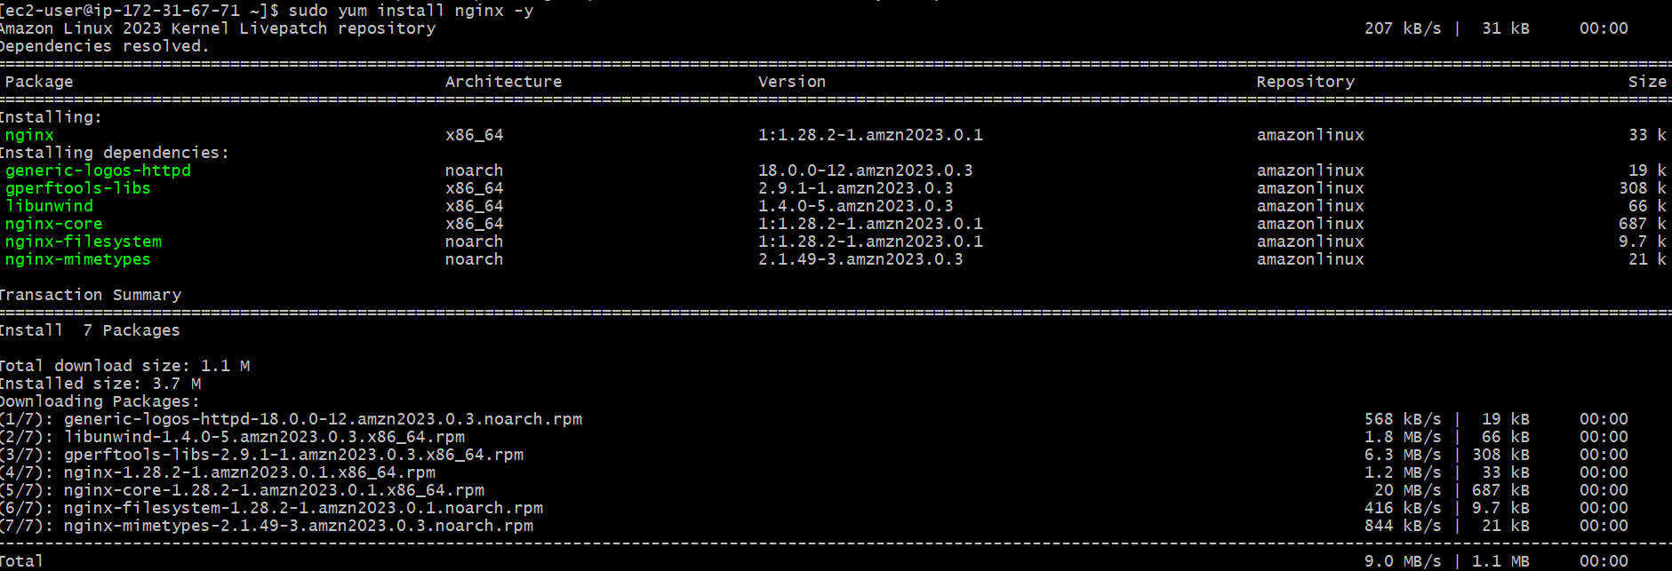
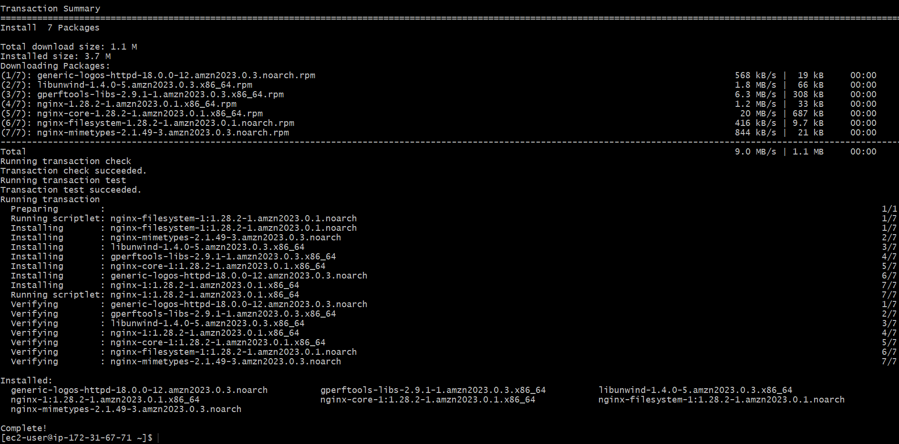
- To check whether it is running or not, first I have started the service and used the below commands
Sudo systemctl start nginx
Sudo systemctl status nginx
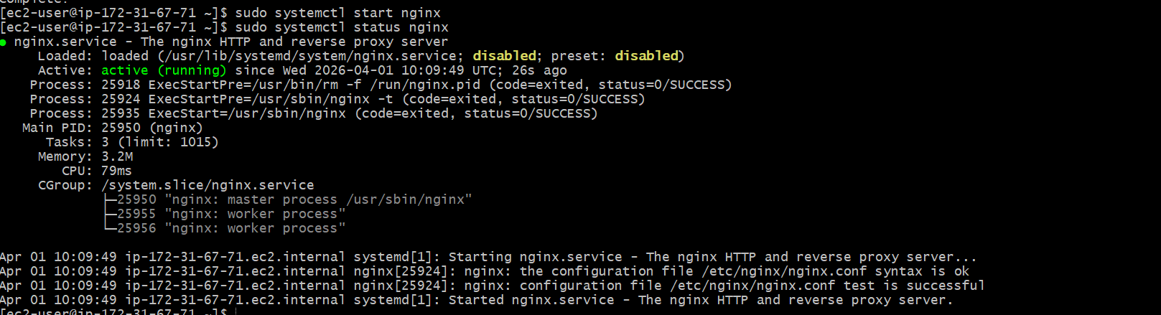
- I have changed the port number from 80 to 81
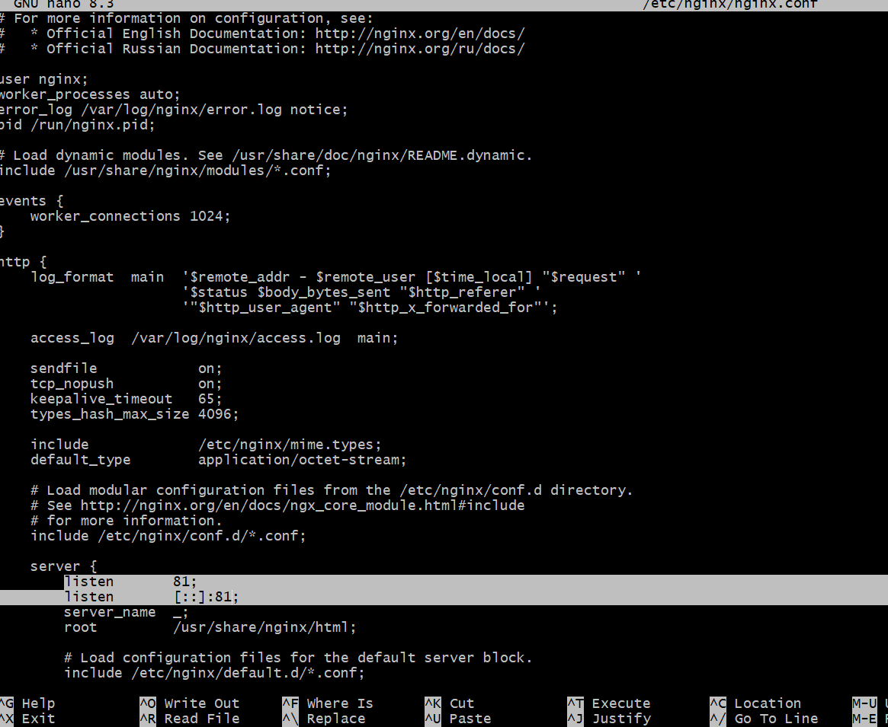
- I have restarted the service and checked the status by below commands
sudo systemctl restart nginx
sudo systemctl start nginx
sudo systemctl status nginx
netstat -na | grep 81
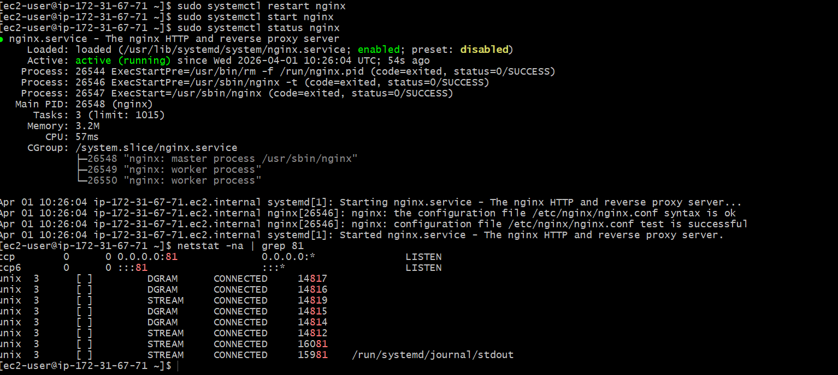
- I have checked in the browser

TASK 2 : Deploy a sample index.html file on nginx.

To deploy a sample index.html file on nginx . I have followed the below commands
cd /usr/share/nginx/html
I gave ‘ls’ to view the file
Cat index.html
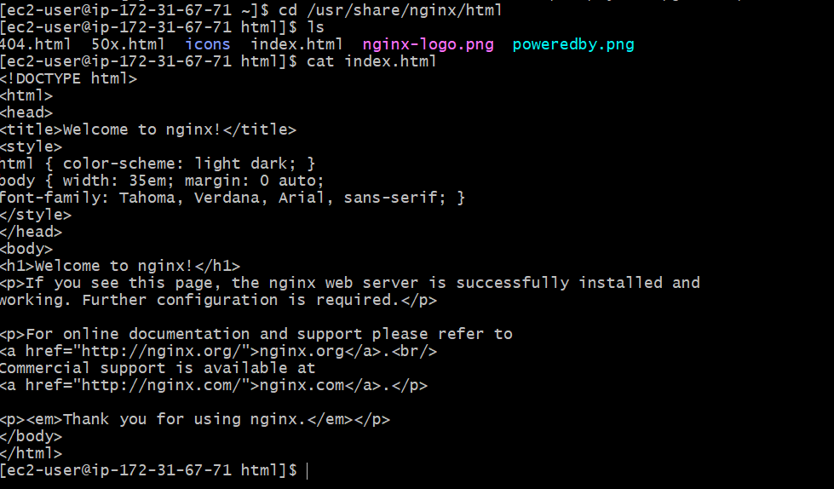

TASK 3 :

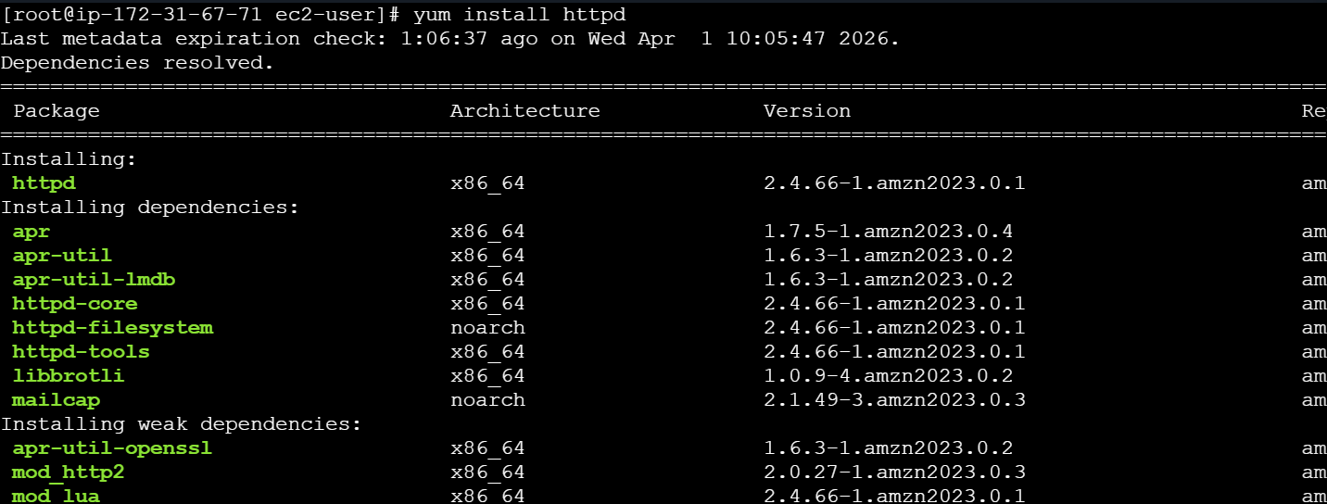
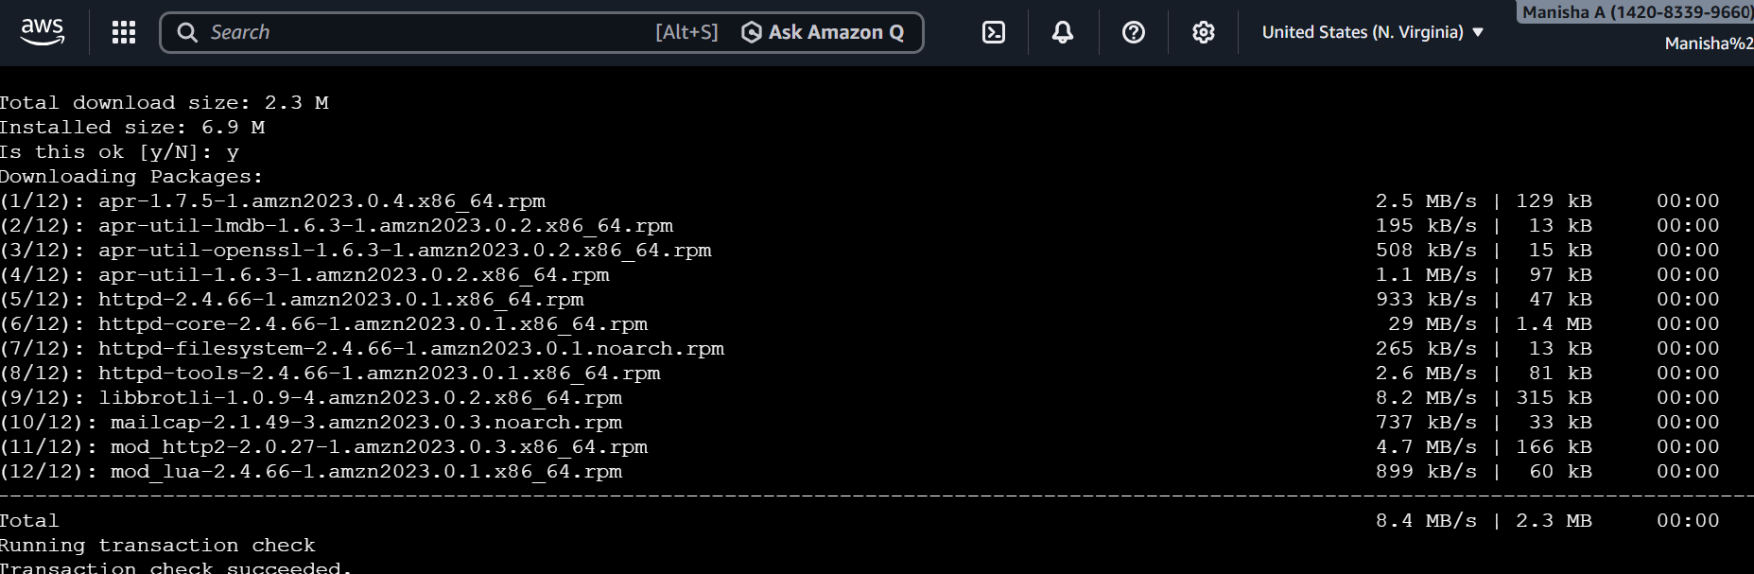
Systemctl start httpd – To start the server
Systemctl status httpd
To check Apache is running or not used below command

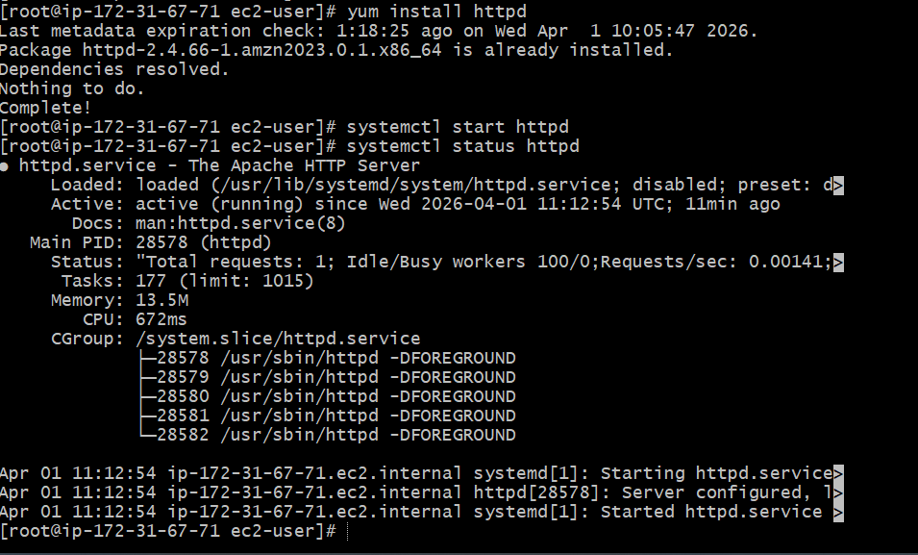
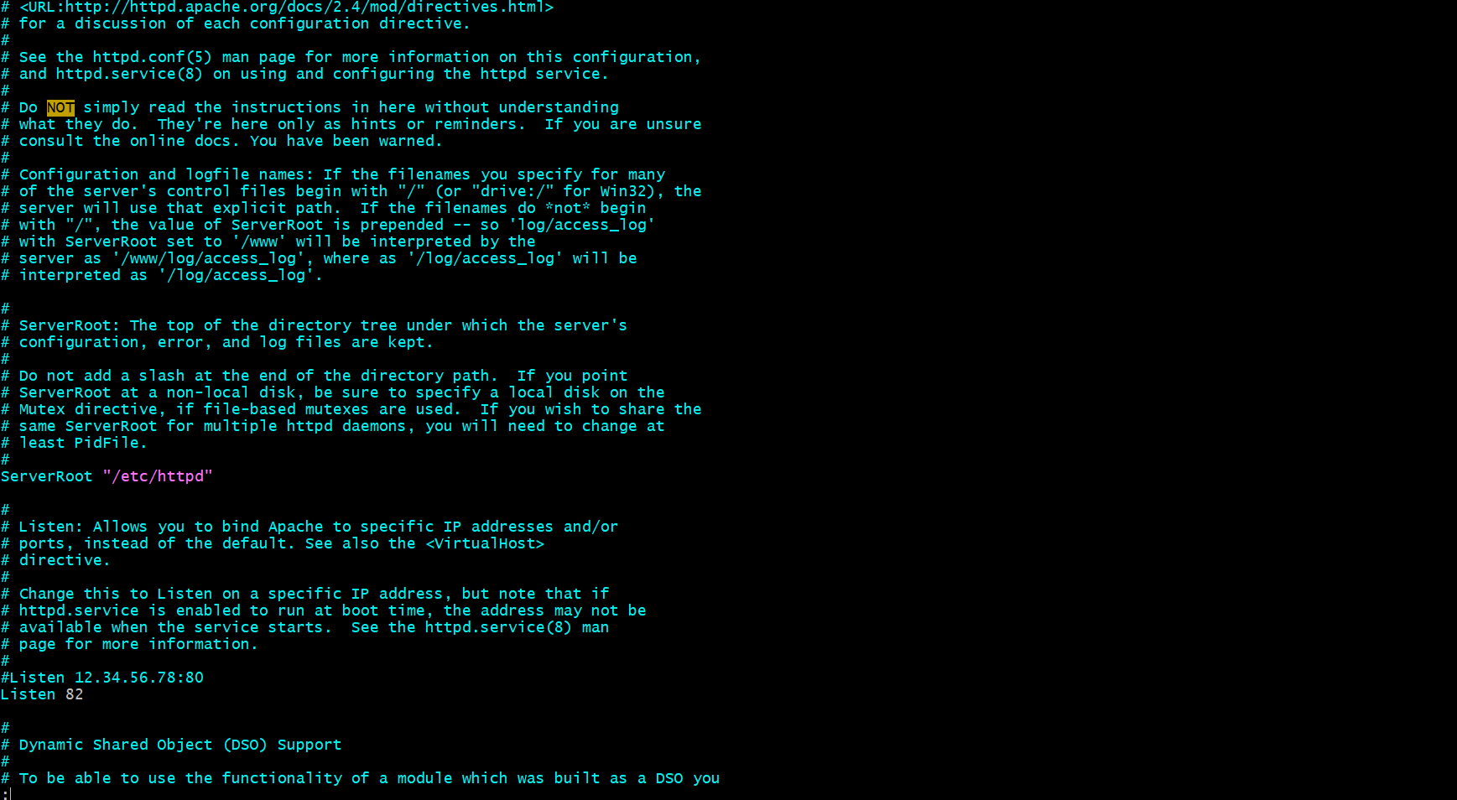
I have restarted the server
Sudo systemctl restart httpd
Sudo systemctl start httpd
Sudo systemctl status httpd
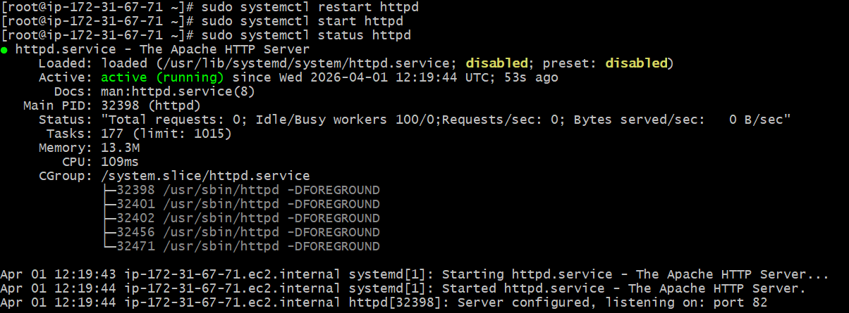
I have checked in browser


Task 4 : Deploy a sample index.html file on Apache.
I have installed apache server
Sudo yum install httpd
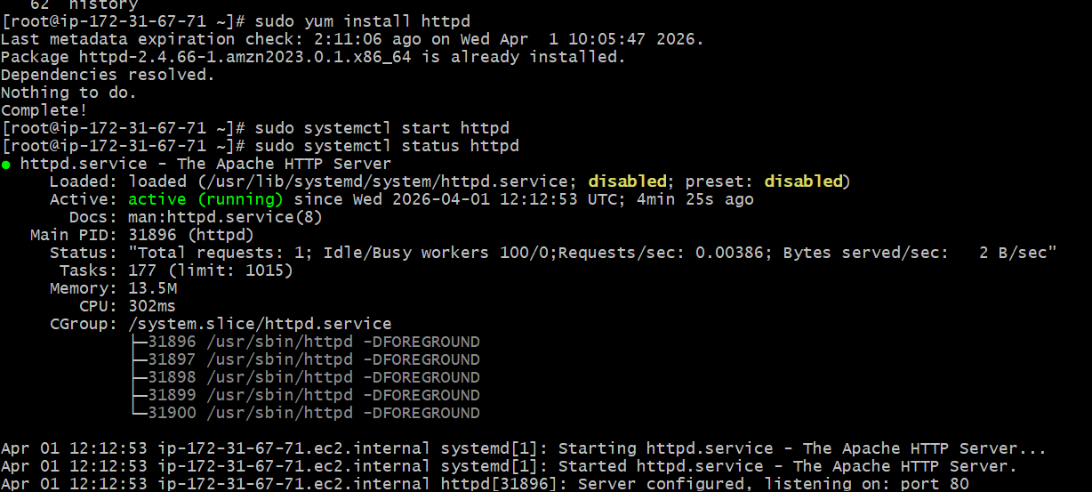
- I have changed the port number to 82
- I have deployed a sample index.html file on server

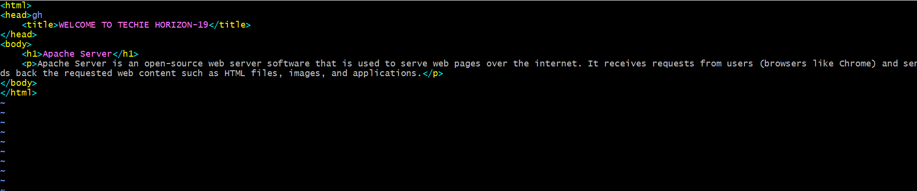
- Checked in the browser
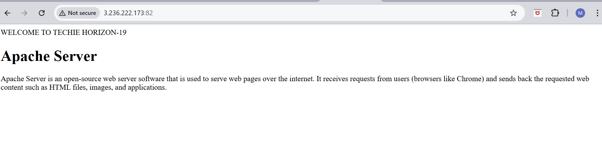

Task 5 : Install Apache tomcat on port number 8082

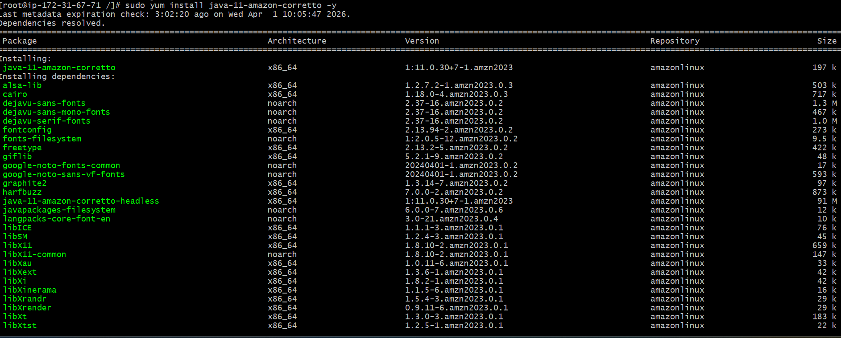

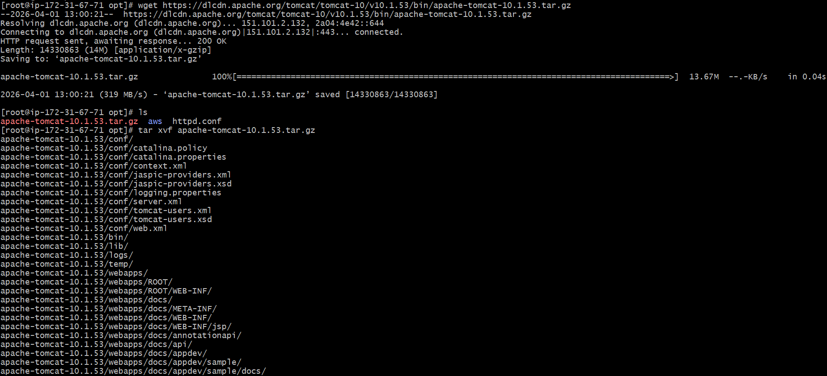

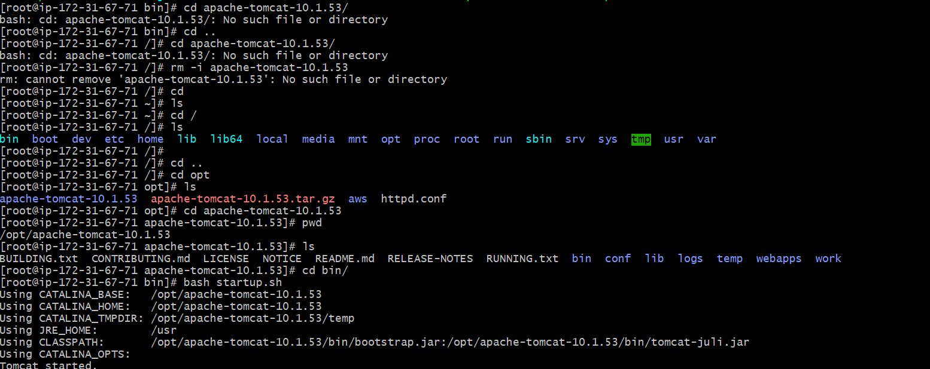
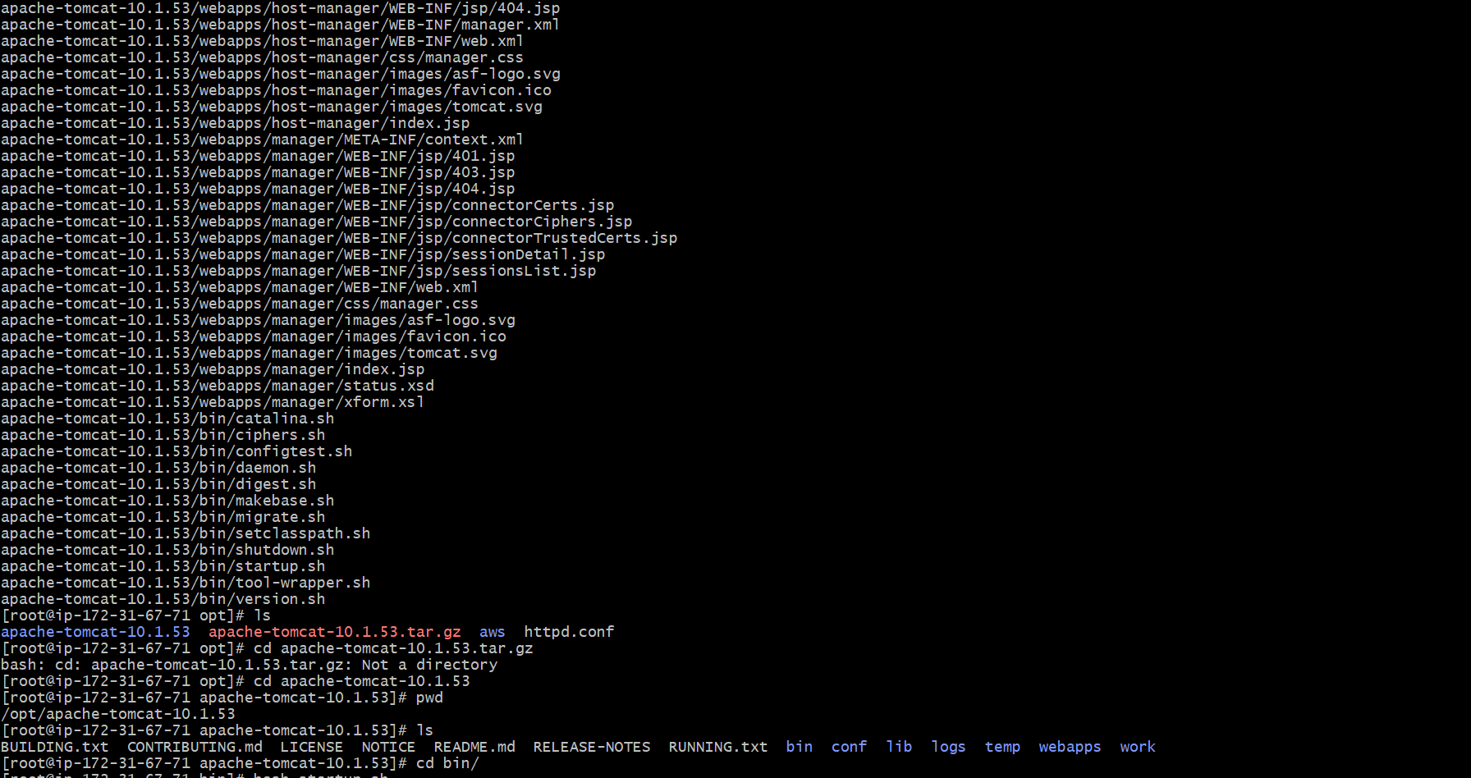
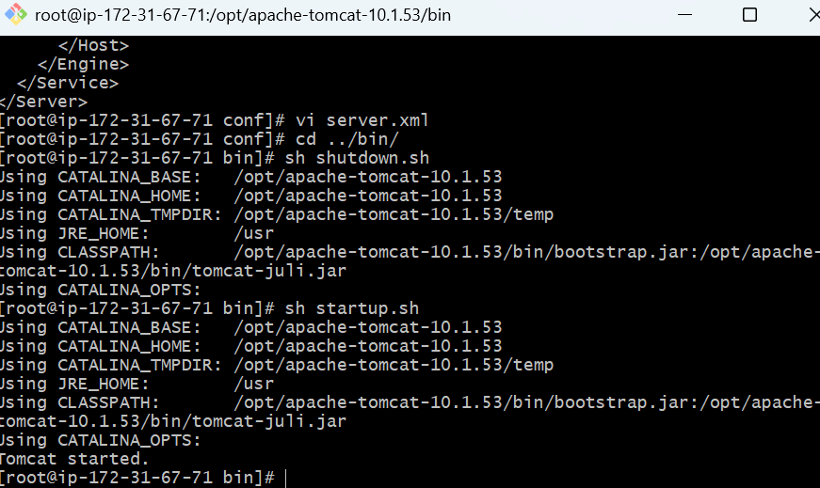

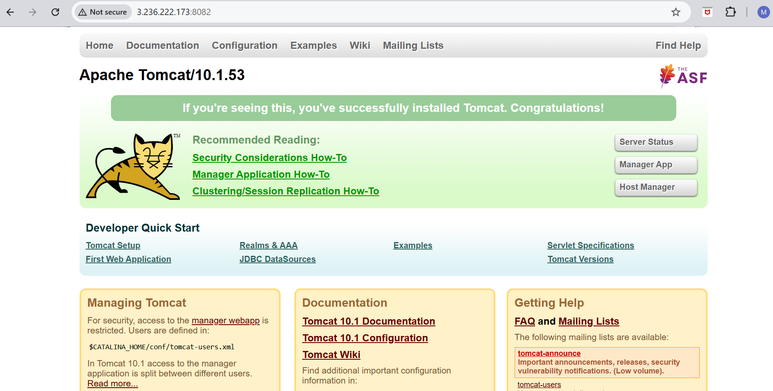

6) Deploy a sample app on webapps
• Navigate to /opt/tomcat/webapps
• Create a new folder (e.g., myapp)
• Inside folder, create index.jsp
• Add sample JSP content
• Save file
• Restart Tomcat
• Verify using browser with
http://<public-ip>:8082/myapp
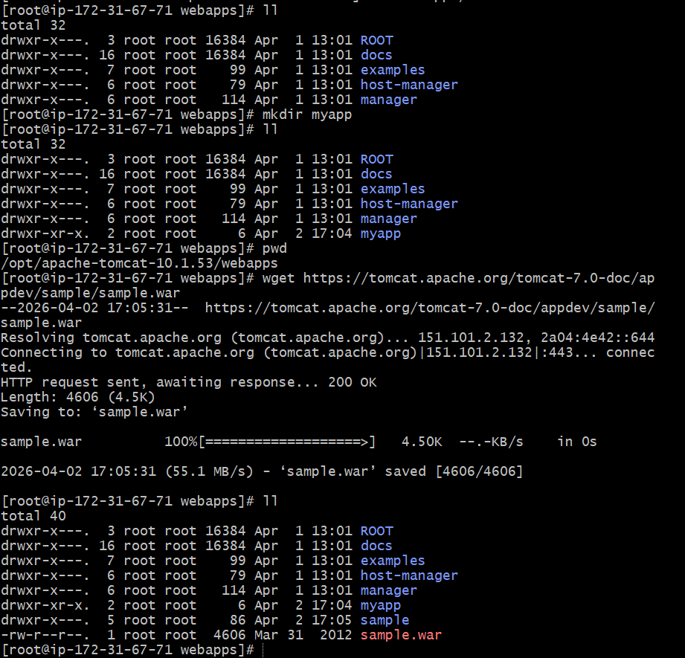
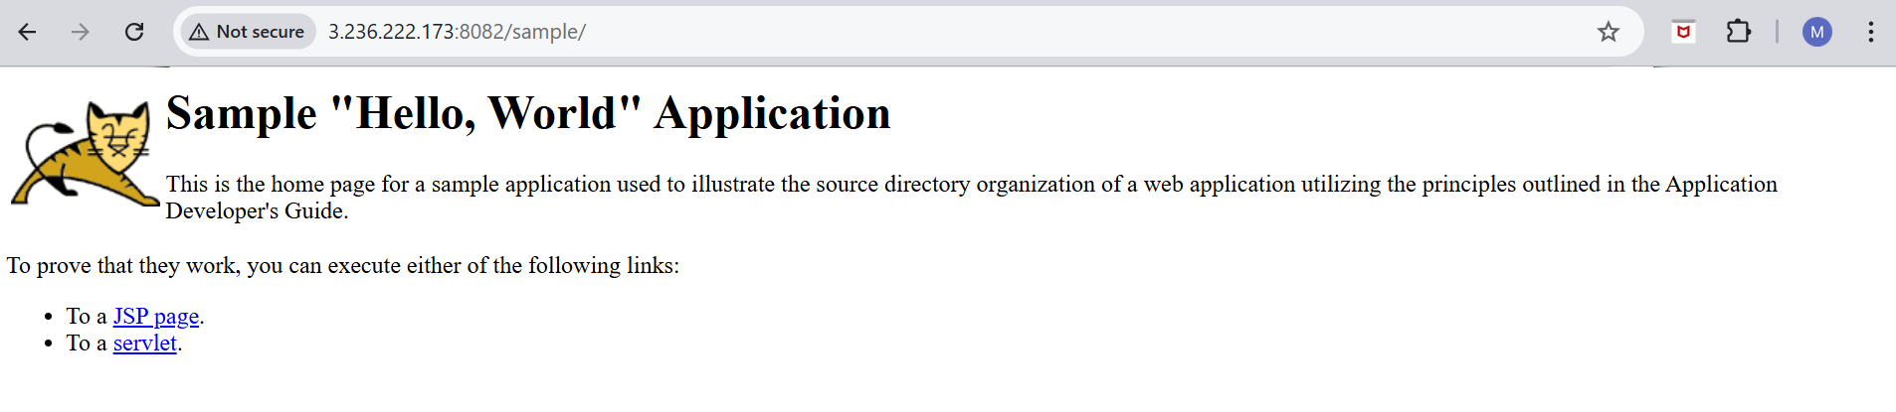
7) Create a tomcat.service file for tomcat.
Use these commands to run this :
- Sudo systemctl daemon-reexec
• sudo systemctl daemon-reload
• sudo systemctl enable tomcat
• systemctl start tomcat
systemctl status tomcat
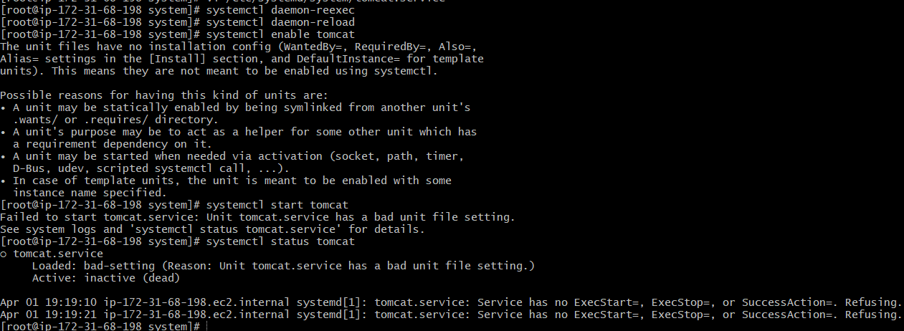
8) Configure HA Proxy server
Steps to follow the HA proxy server
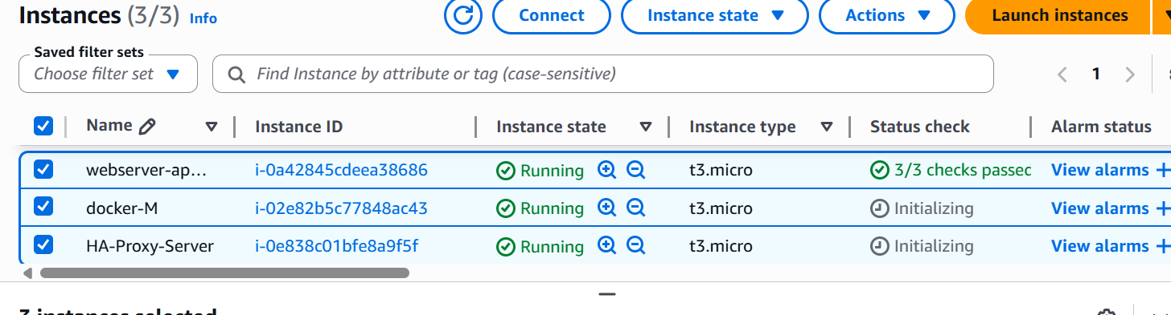

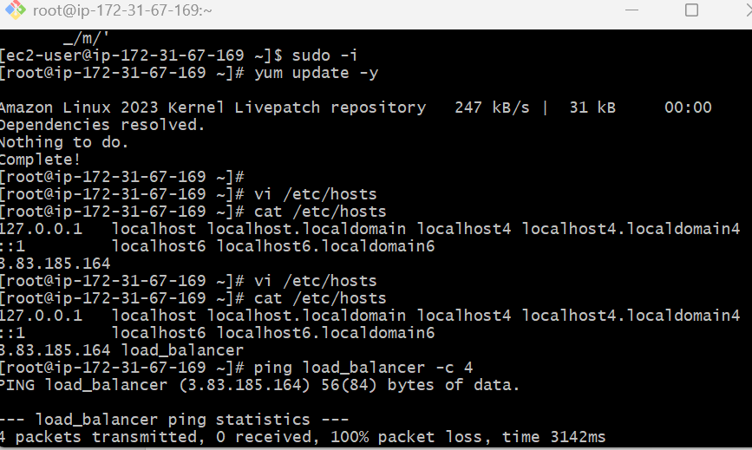
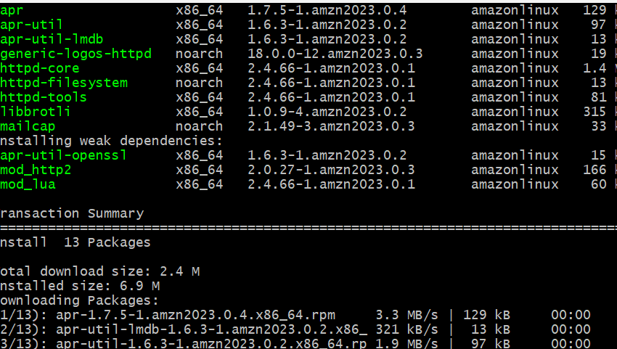
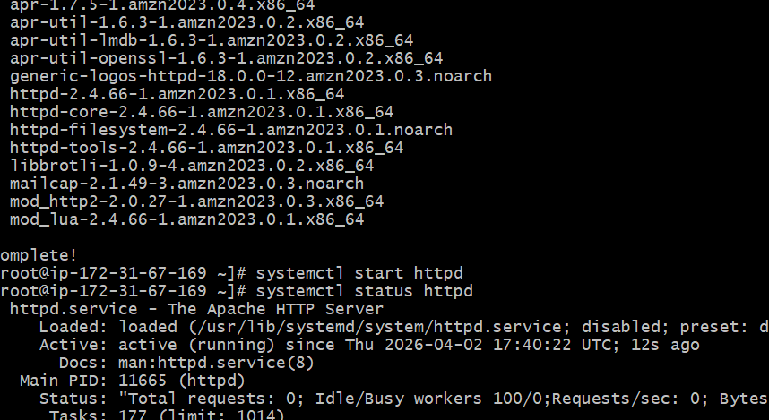
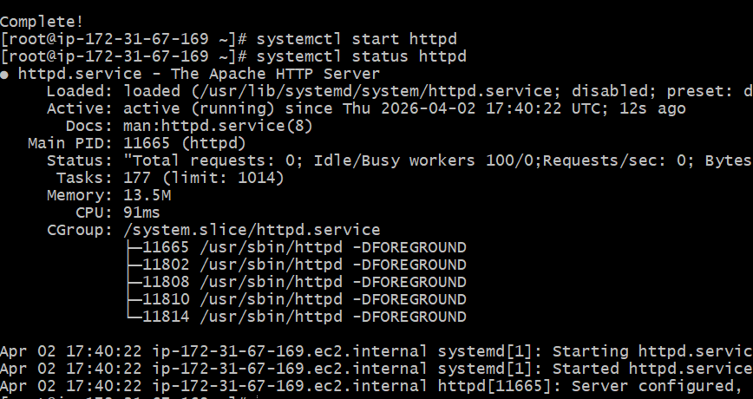
Browser with server1 port no:80 it will work


Server-2 Steps:
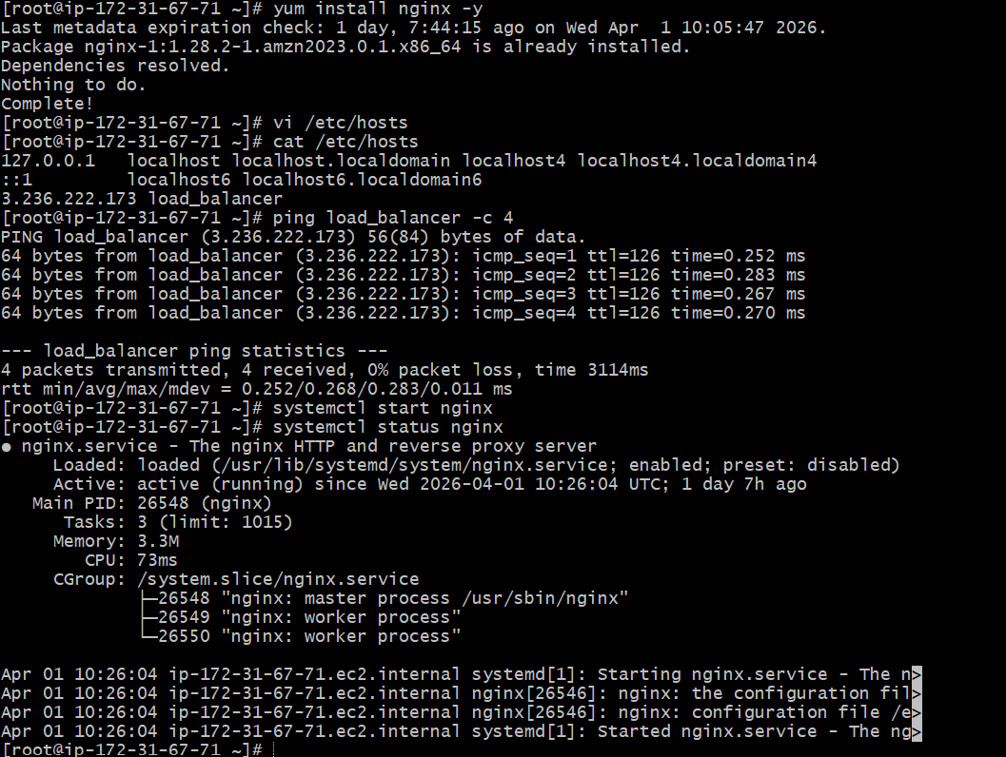
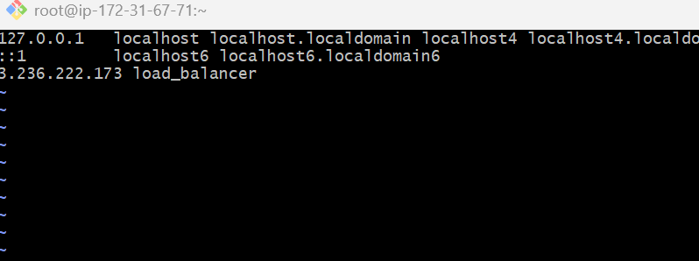
HA-Proxy-Server Steps:
Run following command to Access HA-Proxy-Server

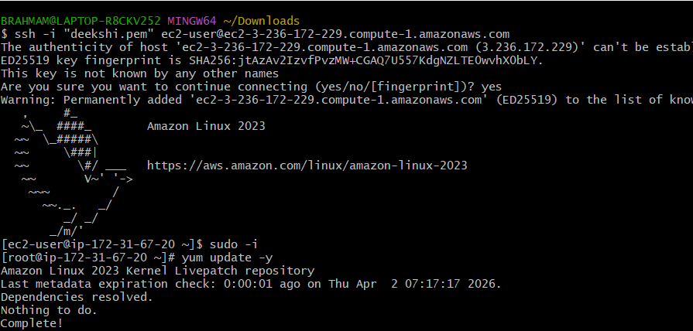
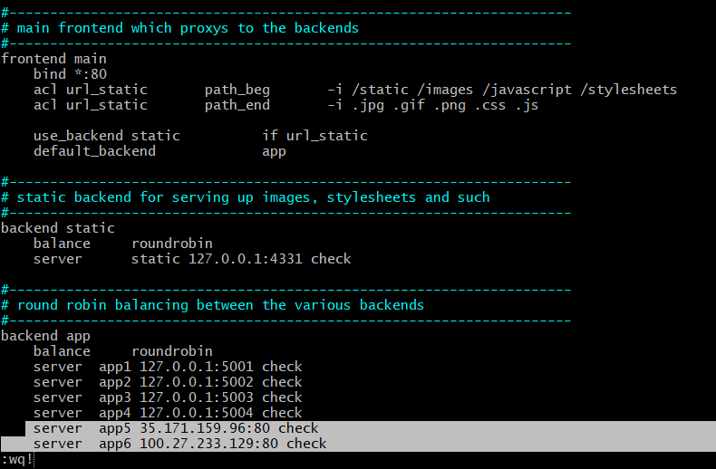
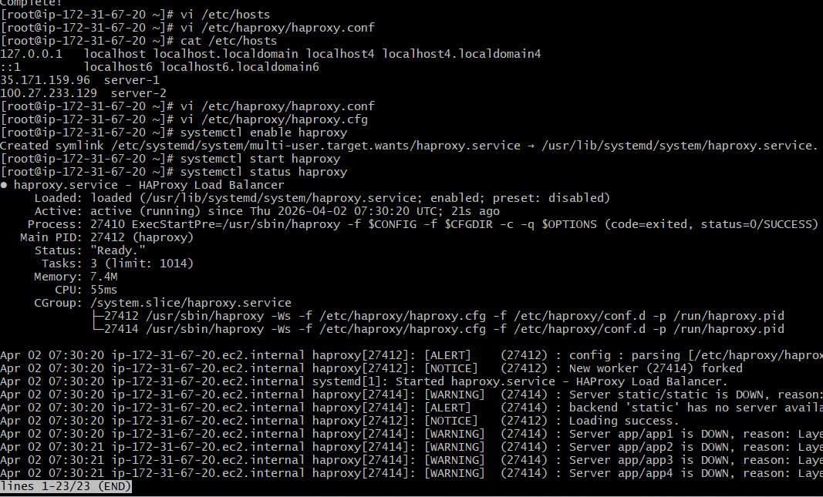
• Now browse with HA-Proxy-Server PublicIP:80 it will distribute load to Server-1, Server-2

